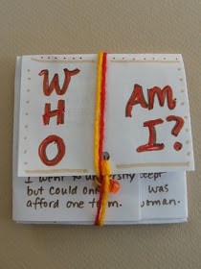
Ideas for bookmaking projects come to me in all sorts of places. Last month I was at a talk by Tuskegee Airman James A. Sheppard at the Newburyport Public Library. He started by describing the history of African American aviation before World war II and showed a photo of the first licensed black aviator in the US—a woman named Bessie Coleman. I immediately knew she would be a perfect subject for March's bookmaking project in celebration of Women's History Month.
Here is a Who Am I? Book about her. This is a simplified version of the book I usually make with a grocery bag and a cereal box panel (directions here). For this one I used two sheets of used copy paper with writing on one side only.
You Will Need:
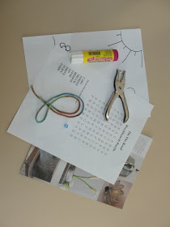
2 sheets used copy paper with writing on one side only
Piece of yarn about an arm's length long
Bead
Glue stick
Scrap paper
Hole punch
Make the Book:
Fold one of the pieces of paper in half the long way like a hot dog with the writing on the inside.
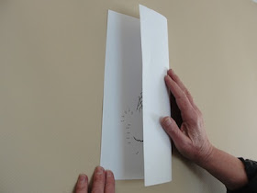

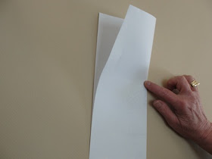
2. Open the paper, put glue on one half, close and smooth to help the glue adhere.
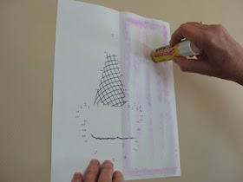

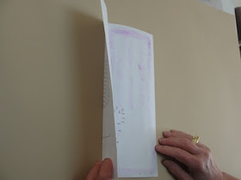

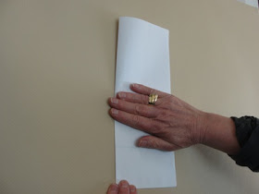
3. Repeat with the second piece of paper.
4. Place one folded piece so that it is tall in front of you. Place the second piece on top to form a large plus sign.
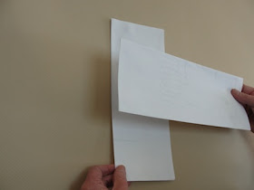

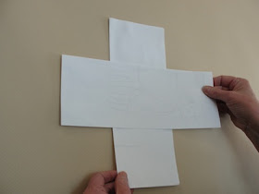
5. Take the bottom of the tall paper and fold it up over the sideways one.
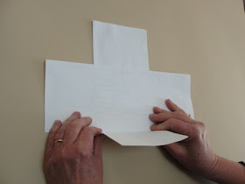

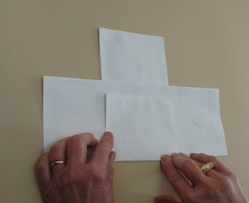
6. Take the right side of the sideways paper and fold it over the bottom you just folded up.
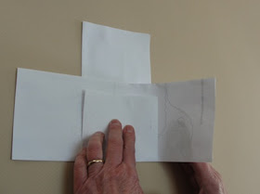

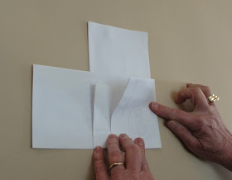
7. Do the same with the left side and the top.
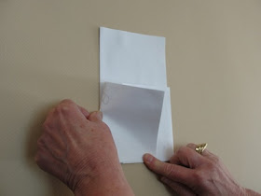

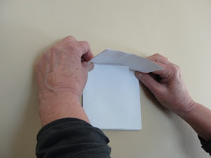
8. Take the two piece of paper apart.
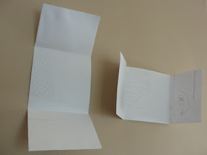
9. Put glue on the center of the tall rectangle, place the sideways piece on top, and smooth to help the glue adhere.
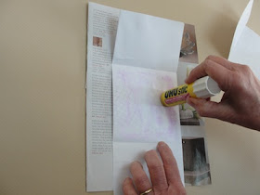

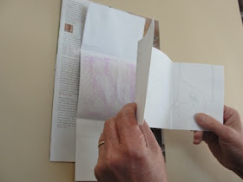

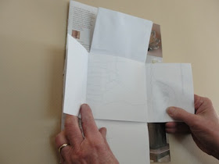

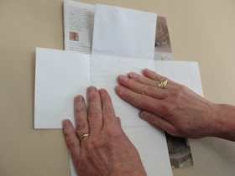
10. Fold the book up.
11. Punch a hole in the center of the lower edge of the top flap.
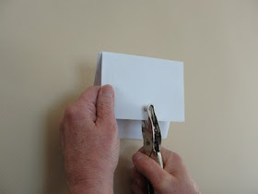

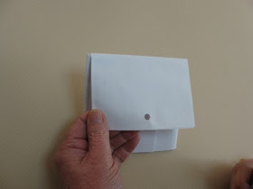
12. Fold the piece of yarn in half.
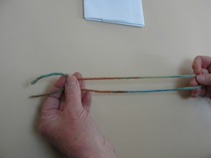
13. Insert the loop end into the hole.
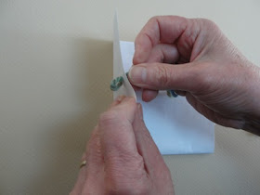
14. Open the loop, put the ends of the yarn through the loop, and pull.
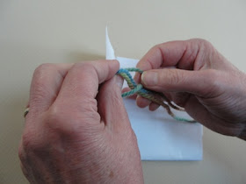

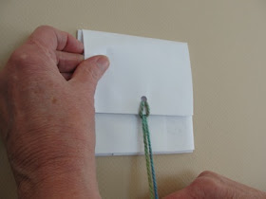
15. Thread both ends of the yarn through a bead (I find it easiest to fold a small loop and twist it before threading) and tie a knot with the bead inside. Tie a second knot to make it secure.
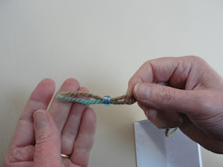

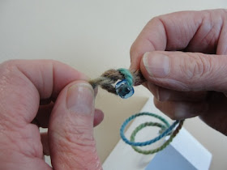
16. To close the book, wrap the yarn around the book and tuck the bead under the yarn.
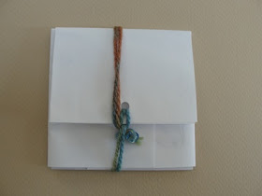
BESSIE'S BOOK

