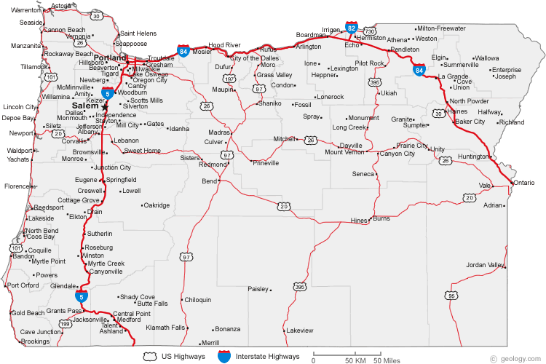

Name | 2016 Population
Portland | 583,776
Eugene | 156,185
Salem | 154,637
Gresham | 105,594
Hillsboro | 91,611
Beaverton | 89,803
Bend | 76,639
Medford | 74,907
Springfield | 59,403
Corvallis | 54,462
Albany | 50,158
Aloha | 49,425
Tigard | 48,035
Lake Oswego | 36,619
Keizer | 36,478
Grants Pass | 34,533
McMinnville | 32,187
Oregon City | 31,859
Redmond | 26,215
Tualatin | 26,054
West Linn | 25,109
Woodburn | 24,080
Newberg | 22,068
Roseburg | 21,181
Forest Grove | 21,083
Klamath Falls | 20,840
Bethany | 20,646
Milwaukie | 20,291
Lents | 20,156
Ashland | 20,078
Hayesville | 19,936
Wilsonville | 19,509
Altamont | 19,257
Sherwood | 18,194
Central Point | 17,169
Hermiston | 16,745
Oak Grove | 16,629
Pendleton | 16,612
Coos Bay | 15,967
Troutdale | 15,962
Four Corners | 15,947
Canby | 15,829
Lebanon | 15,518
Dallas | 14,583
Cedar Mill | 14,546
Happy Valley | 13,903
The Dalles | 13,620
Oatfield | 13,415
La Grande | 13,082
Saint Helens | 12,883
Cornelius | 11,869
Gladstone | 11,497
Ontario | 11,366
Oak Hills | 11,333
Damascus | 10,539
Newport | 9,989
Baker City | 9,828
North Bend | 9,695
Cottage Grove | 9,686
Sandy | 9,570
Monmouth | 9,534
Astoria | 9,477
Rockcreek | 9,316
Prineville | 9,253
Silverton | 9,222
Sweet Home | 8,925
Fairview | 8,920
Independence | 8,590
Eagle Point | 8,469
Florence | 8,466
Cedar Hills | 8,300
Molalla | 8,108
West Haven-Sylvan | 8,001
White City | 7,975
Lincoln City | 7,930
Sutherlin | 7,810
Stayton | 7,644
Green | 7,515
Jennings Lodge | 7,315
Hood River | 7,167
Milton-Freewater | 7,050
Umatilla | 6,906
Sunnyside | 6,791
Clackamas | 6,767
Garden Home-Whitford | 6,674
Scappoose | 6,592
West Slope | 6,554
Seaside | 6,457
Brookings | 6,336
Sheridan | 6,127
Talent | 6,066
Madras | 6,046
West Haven | 6,009
Roseburg North | 5,912
Raleigh Hills | 5,896
Junction City | 5,392
Winston | 5,379
Deschutes River Woods | 5,077
Creswell | 5,031
© 2016 World Population Review

